**ARIGNAR ANNA COLLEGE (ARTS & SCIENCE), KRISHNAGIRI.**

**PG & RESEARCH DEPARTMENT OF COMPUTER SCIENCE.**

**LAB MANUAL – ODD SEM (2023)**

**CLASS: III B. Sc CS**

**SUBJECT: WEB TECHNOLOGY LAB**

**SUBJECT CODE: 21UCSP05**

**SUBMITTED BY,**

**T. SELVAKUMAR,**

**ASST.PROFESSOR,**

**DEPARTMENT OF COMPUTER SCIENCE.**

**PRACTICAL V: WEB TECHNOLOGY LAB - 21UCSP05**

**LIST OF PROGRAMS:**

1. Create a form having number of elements (Textboxes, Radio buttons, Checkboxes, and so on). Write JavaScript code to count the number of elements in a form.

2. Create a HTML form that has number of Textboxes. When the form runs in the Browser fill the Text boxes with data. Write JavaScript code that verifies that all textboxes has been filled. If a text boxes has been left empty, popup an alert indicating which textbox has been left empty.

3. Develop a HTML Form, which accepts any Mathematical expression. Write JavaScript code to Evaluates the expression and Displays the result.

4. Create a page with dynamic effects. Write the code to include layers and basic animation.

5. Write a JavaScript code to find the sum of N natural Numbers. (Use user-defined function).

6. Write a JavaScript code block using arrays and generate the current date in words, this should include the day, month and year.

7. Create a form for Student information. Write JavaScript code to find Total, Average, Result and Grade.

8. Create a form for Employee information. Write JavaScript code to find DA, HRA, PF, TAX, Gross pay, Deduction and Net pay.

9. Create a form consists of a two Multiple choice lists and one single choice list

(a)The first multiple choice list, displays the Major dishes available.

(b)The second multiple choice list, displays the Starters available.

(c)The single choice list, displays the Soft drinks available.

## JavaScript code to count the number of elements in a form.

**AIM:**

To Create a form having number of elements (Textboxes, Radio buttons, Checkboxes, and so on) and to Write JavaScript code to count the number of elements in a form

**ALGORITHM:**

Step 1: Start the program

Step 2: Create html tags

Step 3: Create form

Step 4: Create textboxes, radio button and checkbox

Step 5: write the JavaScript code to count the elements.

Step 6: Execute the form in the browser

Step 7: Stop

**PROGRAM**

<html>

<head>

<title>Registration Form</title>

</head>

<body>

<form id = "form1">

<table border = "1">

<tr>

<td>Choose Your Username</td>

<td><input type = "text" value = "Username" /></td>

</tr>

<tr>

<td>Birthday</td>

<td><select name = "date"><option value = "24" >24</td>

<td><select name = "month"><option value = "feb">feb</td>

<td><select name = "year"><option value = "1991">1991</td>

</tr>

<tr>

<td>Gender</td>

<td><input type = "radio" name = "gender"/>Male</td>

<td><input type = "radio" name = "gender"/>Female</td>

</tr>

<tr>

<td><input type = "checkbox" /> I agree the terms and policy</td>

</tr>

<tr>

<td><input type = "button" value = "create" /></td>

</tr>

</table>

</form>

<p>Click the button to display the number of elements in the form.</p>

<button onclick="myFunction()">No of elememts</button>

<p id="demo"></p>

<script> functionmyFunction() {

var x = document.getElementById("form1").elements.length; document.getElementById("demo").innerHTML = "Found " + x + " elements in the form.";

}

</script>

</body>

</html>

## OUTPUT

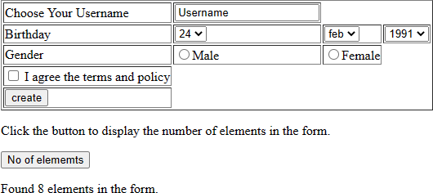

**RESULT:**

Thus, the web page is designed and the output is verified successfully.

1. **Popup an alert indicating which textbox has been left empty.**

**AIM:**

To Write JavaScript code that verifies that all textboxes has been filled. If a text boxes has been left empty, popup an alert indicating which textbox has been left empty.

**ALGORITHM:**

Step 1: Start the program

Step 2: Create html tags

Step 3: Create form

Step 4: Create textboxes

Step 5: write the JavaScript code to popup an alert.

Step 6: Execute the form in the browser

Step 7: Stop

## PROGRAM

<html>

<head>

<title>Registration Form</title>

<script type = "text/javascript"> function validate()

{

if(document.myForm.Name.value == "")

{

alert("Please Provide Your Name"); document.myForm.Name.focus(); return false;

}

if(document.myForm.Email.value == "")

{

alert("Please Provide Your Email ID"); document.myForm.Email.focus(); return false;

}

if ((document.myForm.Zip.value == "")||(document.myForm.Zip.value.length != 5))

{

alert("Please Provide a valid zip code format #####"); document.myForm.Zip.focus();

return false;

}

if(document.myForm.Country.value == "-1")

{

alert("Please Provide Your Country Name"); return false;

}

return true;

}

function validateEmail()

{

varemailID = document.myForm.Email.value; atpos = emailID.indexOf("@");

dotpos = emailID.lastIndexOf("."); if(atpos< 1 || (dotpos - atpos< 2))

{

alert("Please Enter Correct Email ID"); document.myForm.Email.focus(); return false;

}

return true;

}

</script>

</head>

<body >

<form name = "myForm" onsubmit = "return(validate());" >

<table cellspacing = "2" cellpadding = "2" border = "1">

<tr>

<td>Name</td>

<td><input type = "text" name = "Name" /></td>

</tr>

<tr>

<td>Email ID</td>

<td><input type = "text" name = "Email" onchange = "validateEmail();"/></td>

</tr>

<tr>

<td>Zip Code</td>

<td><input type = "text" name = "Zip" /></td>

</tr>

<tr>

<td>Country</td>

<td><select name = "Country" >

<option value = "-1" selected> [Choose Yours]</option>

<option value = "1" >INDIA</option>

<option value = "2" >USA</option>

<option value = "3" >Srilanka</option>

</select>

</td>

</tr>

<tr>

<td colspan = "2" align = "center"><input type = "submit" value = "Submit" /></td>

</tr>

</table>

</form>

</body>

</html>

## OUTPUT

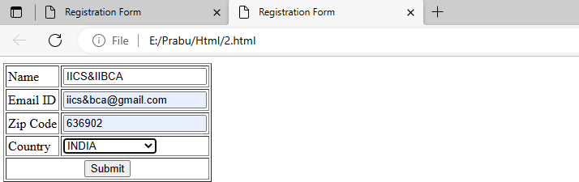

**After Clicking Submit Button**

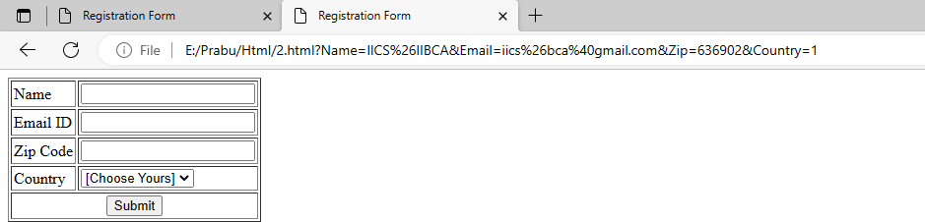

## Popup an Alert Indicating Which Textbox Has Been Left Empty

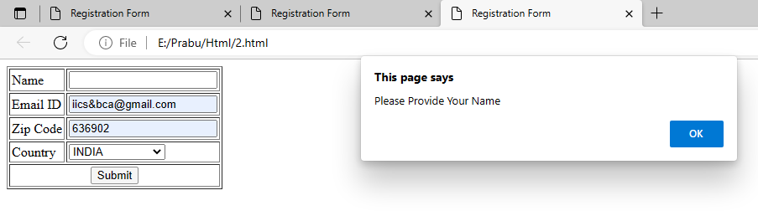

**RESULT:**

Thus the web page is designed and the output is verified successfully.

1. **HTML Form, which accepts Mathematical expression.**

**AIM:**

To Develop a HTML Form, which accepts any Mathematical expression and to write the JavaScript code to evaluates the expression and Displays the result.

**ALGORITHM:**

Step 1: Start the program

Step 2: Create html tags

Step 3: Create form

Step 4: Create textboxes

Step 5: write the JavaScript code to evaluate the mathematical expression.

Step 6: Execute the form in the browser

Step 7: Stop

## PROGRAM

<html>

<head>

<title>Arithmetic Operations</title>

</head>

<body>

<script type="text/javascript"> var a = 12;

var b = 34; var result;

document.write("Value of a = " + a + " and b = "+ b); result = a + b;

document.write("<br>Addition of a & b = " + result ); result = a - b;

document.write("<br>Subtraction of a & b = " + result ); result = a * b;

document.write("<br>Multiplication of a & b = " + result ); result = a / b;

document.write("<br>Division of a & b = " + result );

</script>

</body>

</html>

## OUTPUT

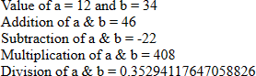

**RESULT:**

Thus the web page is designed and the output is verified successfully.

1. **Web page with dynamic effects.**

**AIM:**

To create a page with dynamic effects and to write the code to include layers and basic animation

**ALGORITHM:**

Step 1: Start the program

Step 2: Create html tags

Step 3: Using imgsrc specify image

Step 4: Use function move Image () to move an image

Step 5: Execute the coding in browser

Step 6: Stop

## PROGRAM

**<**html>

<head>

<style>

.moveable{ position: absolute;

}

</style>

<script type = "text/javascript"> var x = 5;

var y = 5; vardest_x = 300;

vardest_y = 300; var interval = 10;

function moveImage()

{

if(x <dest_x)

x = x + interval; if(y <dest_y)

y = y + interval; document.getElementById("ufo").style.top = y + "px"; document.getElementById("ufo").style.left = x + "px"; if((x + interval <dest_x) && (y + interval <dest_y))

{

window.setTimeout("moveImage()", 100);

}

}

</script>

</head>

<body onload = "moveImage()">

<div id = "ufo" class = "moveable">

<imgsrc = "image.jpg" alt = "please link to a valid image" />

</div>

</body>

</html>

## OUTPUT

**RESULT:**

Thus the web page is designed and the output is verified successfully.

**5. JavaScript code to find the sum of N natural Numbers. (Use user-defined function)**

**AIM:**

To write a JavaScript code to find the sum of N natural Numbers using user defined function

**ALGORITHM:**

Step 1: Start the program

Step 2: Create html tags

Step 3: Declare and initialize the variables

Step 4: Use function sumnaturalno(n) to sum the N natural numbers

Step 5: Execute the coding in browser

Step 6: Stop

## PROGRAM

<html>

<head>

<script type = "text/javascript">

varnum = window.prompt("Enter the number:",""); var n = parseInt(num);

result = sumnaturalno(n);

window.alert("The sum of " + n + "natural number is" + result); function sumnaturalno(n)

{

var i;

var sum = 0;

for(i = 1;i <= n; i++){ sum = sum + i;}

return (sum);

}

</script>

</head>

</html>

## OUTPUT

Enter the number:5

The sum of 5natural number is 15

**RESULT:**

Thus the web page is designed and the output is verified successfully.

## JavaScript code to generate the current date in words, including the day, month and year.

**AIM:**

To Write a JavaScript code block using arrays and generate the current date in words, this should includes the day, month and year.

**ALGORITHM:**

Step 1: Start the program

Step 2: Create html tags

Step 3: Declare and initialize the variables

Step 4: Use array to generate day month and year

Step 5: Execute the coding in browser

Step 6: Stop

**PROGRAM**

<html>

<head>

<script type = "text/javascript"> var d = new Date();

var weekday = new

Array("Sunday","Monday","Tuesday","Wednesday","Thursday","Friday", "Saturday")

varmonthname = new

Array("Jan","Feb","Mar","Apr","May","Jun","Jul","Aug","Sep","Oct","Nov", "Dec");

document.write(weekday[d.getDay()] + " "); document.write(d.getDate() + ". "); document.write(monthname[d.getMonth()] + " "); document.write(d.getFullYear());;

</script>

</head>

<body>

</body>

</html>

## OUTPUT

Saturday 13. Nov 2021

**RESULT:**

Thus the web page is designed and the output is verified successfully.

# JavaScript code to find Total, Average, Result and Grade.

**AIM:**

To create a form for Student information. Write JavaScript code to find Total, Average, Result and Grade.

**ALGORITHM:**

Step 1: Start the program

Step 2: Create html tags

Step 3: Create form

Step 4: Create textboxes and submit

Step 5: Write the java script code to find result

Step 6: Execute the coding in browser

Step 7: Stop

**PROGRAM**

<!DOCTYPE html>

<html lang="en">

<head>

<meta charset="UTF-8">

<meta name="viewport" content="width=device-width, initial-scale=1.0">

<title>Grading System in Javascript</title>

</head>

<body style="background-color: skyblue">

<center>

<h1 style="margin-top: 10px">Student Information</h1>

</center>

<div id="main">

<div id="head"><h1>Find Total, Average And Grade</h1></div>

<label>Web Technology</label><input type="text" id="eng"><br>

<label>RDBMS</label><input type="text" id="mat"><br>

<label>Networks</label><input type="text" id="phy"><br>

<label>OS</label><input type="text" id="chm"><br>

<label>Data Structure</label><input type="text" id="cmp"><br>

<br>

<button class="btn1" onclick="Total()">Total</button>

<button class="btn2" onclick="Average()">Average</button>

<button class="btn3" onclick="Grade()">Grade</button>

</div>

<div id="result">

<div id="head1"><h1>Total</h1></div>

<div id="total">

</div>

<div id="head2"><h1>Average</h1></div>

<div id="avg">

</div>

<div id="head3"><h1>Grade</h1></div>

<div id="grade">

</div>

</div>

<script>

function Total(){

var sub1 = parseInt(document.getElementById("eng").value); var sub2 = parseInt(document.getElementById("mat").value); var sub3 = parseInt(document.getElementById("phy").value); var sub4 = parseInt(document.getElementById("chm").value); var sub5 = parseInt(document.getElementById("cmp").value); if(sub1>100 || sub2>100 || sub3>100 || sub4>100 || sub5>100 )

{

alert("Please Enter Marks in range of 100");

}

else {

var total= sub1 + sub2 + sub3 + sub4 + sub5; document.getElementById("total").innerHTML = "English Marks :"+sub1+"<br> Maths

Marks: "+sub2+"<br> Physics Marks: "+sub3+"<br> Chemistry Marks: "+sub4+"<br> Computer Marks: "+sub5+"<br> Total Marks: "+total;

}

}

function Average(){

var sub1 = parseInt(document.getElementById("eng").value); var sub2 = parseInt(document.getElementById("mat").value); var sub3 = parseInt(document.getElementById("phy").value); var sub4 = parseInt(document.getElementById("chm").value); var sub5 = parseInt(document.getElementById("cmp").value);

if(sub1>100 || sub2>100 || sub3>100 || sub4>100 || sub5>100 )

{

alert("Please Enter Marks in range of 100");

}

else {

var total= sub1 + sub2 + sub3 + sub4 + sub5; var avg=total/5;

document.getElementById("avg").innerHTML="Your Average marks are: "+avg;

}

}

function Grade(){

var sub1 = parseInt(document.getElementById("eng").value); var sub2 = parseInt(document.getElementById("mat").value); var sub3 = parseInt(document.getElementById("phy").value); var sub4 = parseInt(document.getElementById("chm").value); var sub5 = parseInt(document.getElementById("cmp").value);

if(sub1>100 || sub2>100 || sub3>100 || sub4>100 || sub5>100 )

{

alert("Please Enter Marks in range of 100");

}else {

var total= sub1 + sub2 + sub3 + sub4 + sub5; var avg=total/5;

if(avg>=80 && avg<=100)

{

document.getElementById("grade").innerHTML="You Got A+ Grade";

}

else if(avg>=75 && avg<=80)

{

document.getElementById("grade").innerHTML="You Got A+ Grade";

}

else if(avg>=70 && avg<=75)

{

document.getElementById("grade").innerHTML="You Got A Grade";

}

else if(avg>=65 && avg<=70)

{

document.getElementById("grade").innerHTML="You Got B Grade";

}

else if(avg>=50 && avg<=60)

{

document.getElementById("grade").innerHTML="You Got C Grade";

}

else if(avg>=40 && avg<=50)

{

document.getElementById("grade").innerHTML="You Got C Grade";

}

else {

document.getElementById("grade").innerHTML="You Got F Grade";

}

}

}

</script> </body> </html>

## OUTPUT

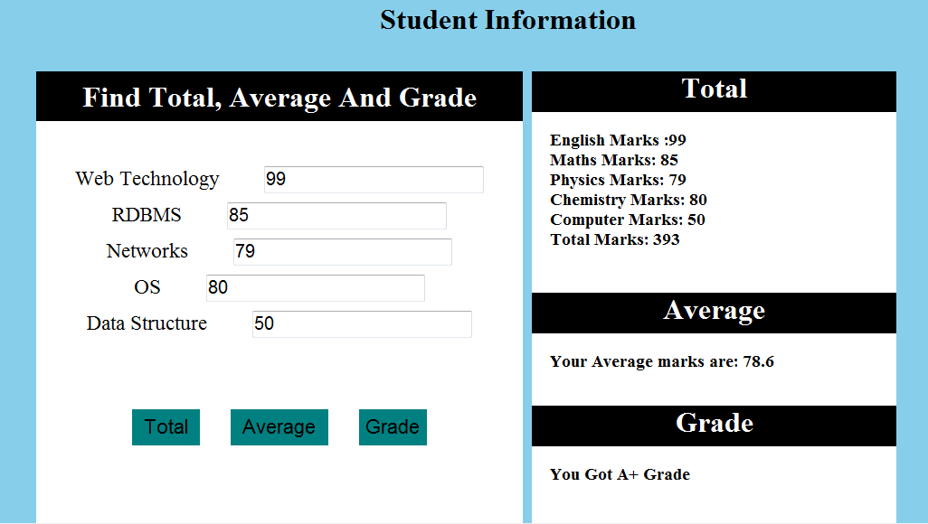

**RESULT:**

Thus the web page is designed and the output is verified successfully.

1. **Finding DA, HRA, PF, TAX, Gross pay, Deduction and Net pay.**

**AIM:**

To create a form for Employee information. Write JavaScript code to find DA, HRA, PF, TAX, Gross pay, Deduction and Net pay

**ALGORITHM:**

Step 1: Start the program

Step 2: Create html tags

Step 3: Create form

Step 4: Create textboxes and button

Step 5: use function calc() to get the result

Step 6: Execute the coding in browser

Step 7: Stop

## PROGRAM

<html>

<head>

<title>Registration Form</title>

<script type = "text/javascript"> function calc()

{

varbp,DA,HRA,GP,PF,Tax,Deduction,NetPay,name,id,desg; name = document.form1.firstname.value;

id = document.form1.userid.value;

desg = document.form1.designation.value; bp = parseInt(document.form1.bp.value); DA = bp * 0.5;

HRA = bp * 0.5;

GP = bp + DA + HRA; PF = GP * 0.02;

Tax = GP * 0.01;

Deduction = Tax + PF; NetPay = GP - Deduction;

document.form1.da.value = DA; document.form1.hra.value = HRA; document.form1.gp.value = GP; document.form1.pf.value = PF; document.form1.tax.value = Tax; document.form1.deduction.value = Deduction; document.form1.netpay.value = NetPay

}

</script>

</head>

<body >

<form name = "form1">

<table border = "1">

<tr>

<td>Name</td>

<td><input type = "text" name = "firstname" /></td>

</tr>

<tr>

<td>User ID</td>

<td><input type = "text" name = "userid" /></td>

</tr>

<tr>

<td>Designation</td>

<td><input type = "text" name = "designation" /></td>

</tr>

<tr>

<td>Basic Pay</td>

<td><input type = "text" name = "bp"></td>

</tr>

<tr>

<td colspan = "2" align = "center">

<input type = "button" name = "calculate" value = "Click Here ToCalculate"onclick

="calc()"></td>

</tr>

<tr>

<td>Dearness Allowance </td>

<td><input type = "text" name = "da"/></td>

</tr>

<tr>

<td>House Rent Allowance </td>

<td><input type = "text" name = "hra"></td>

</tr>

<tr>

<td>GP</td>

<td><input type = "text" name = "gp"></td>

</tr>

<tr>

<td>Provident Fund</td>

<td><input type = "text" name = "pf" /></td>

</tr>

<tr>

<td>Tax</td>

<td><input type = "text" name = "tax" /></td>

</tr>

<tr>

<td>Deduction</td>

<td><input type = "text" name = "deduction" /></td>

</tr>

<tr>

<td>NetPay</td>

<td><input type = "text" name = "netpay" /></td>

</tr>

</table>

</form>

</body>

</html>

## OUTPUT

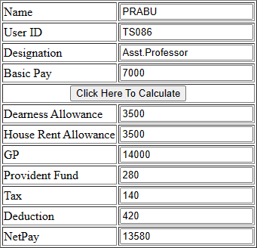

**RESULT:**

Thus the web page is designed and the output is verified successfully.

1. **Form consists of a two Multiple choice lists and one single choice list.**

**AIM:**

To create a form consists of a two Multiple choice lists and one single choice list.

**ALGORITHM:**

Step 1: Start the program

Step 2: Create html tags

Step 3: Create form

Step 4: Declare and initialize the variables

Step 5: Use select element and write the option values

Step 6: Execute the coding in browser

Step 7: Stop

**PROGRAM**

<html>

<head>

<script type = "text/javascript"> functionfindcost()

{

var major = document.getElementById("major"); var Starters = document.getElementById("starters"); var soft = document.getElementById("soft");

var s = "Item \t \t \t Price \n \n";

vartotalcost = 0;

for(var i = 0; i<major.options.length; i++)

{

var option = major.options[i]; if(option.selected == true)

{

var price = parseInt(option.value); totalcost = totalcost + price;

s = s+ option.text + "\t \t" + price + "\n";

}

}

for(var i = 0; i<starters.options.length; i++)

{

var option = starters.options[i]; if(option.selected == true)

{

var price = parseInt(option.value); totalcost = totalcost + price;

s = s + option.text + "\t \t" + price + "\n";

}

}

Varsoftdrinkindex = soft.selectedIndex; if(softdrinkindex != null)

{

varselectedsoftdrink = soft.options[soft.selectedIndex].text; var price = parseInt(soft.options[soft.selectedIndex].value); totalcost = totalcost + price;

s = s + selectedsoftdrink + "\t \t" + price + "\n";

}

s = s + "\n\n Total Cost \t \t" + totalcost; document.getElementById("ordereditems").value = s;

}

</script>

</head>

<body>

<form name = "menuForm">

<table border = "1" >

<tr>

<td colspan = "2" align = "center">

<h2>Restaurant Menu Details</h2>

</td>

</tr>

<tr>

<td> Major Dishes:</td>

<td>

<select id = "major" size = "3" multiple = "multiple">

<option value = "100"> Vegetable Pulav</option>

<option value = "150">HyderabadiBiriyani</option>

<option value = "50"> Roti with Curry </option>

</select>

</td>

</tr>

<tr>

<td> Starters </td>

<td><select id = "starters" size = "3" multiple = "multiple">

<option value = "80"> Gobi Manchurian </option>

<option value = "40"> Veg Clear Soup </option>

<option value = "30"> Masala Papad</option>

</td>

</tr>

<tr><td>Soft Drinks</td>

<td>

<select id = "soft" size = "3" multiple = "multiple">

<option value = "20"> Pepsi</option>

<option value = "25"> Coke </option>

<option value = "30"> Lime Soda </option>

</select>

</td>

</tr>

<tr>

<td colspan = "2" align = "center">

<textarea id = "ordereditems" rows = "10" cols = "40">

</textarea>

</td>

</tr>

<tr>

<td>

<input type = "button" value = "Find total Cost" onclick = "findcost()" />

</td>

<td>

<input type = "reset" value = "Clear" />

</td>

</tr>

</table>

</form>

</body>

</html>

## OUTPUT

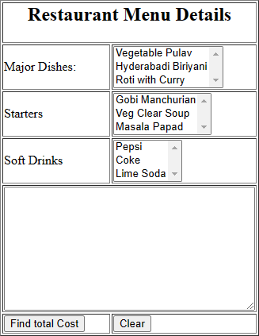

**RESULT:**

Thus the web page is designed and the output is verified successfully

1. **On Mouse Over and On Mouse out event handlers.**

**AIM:**

To create a web page using two image files, which switch between one another as the mouse pointer moves over the image. Using the on Mouse Over and on Mouse Out event handlers.

**ALGORITHM:**

Step 1: Start the program

Step 2: Create html tags

Step 3: Using imgsrc specify image

Step 4: Use the java script functions mouseover() and mouseout()

Step 6: Execute the coding in browser

## Step 7: Stop

## PROGRAM

<html>

<head>

<script type = "text/javascript"> function mouseover() {

document.getElementById("img").src = "C:\Users\tamil\Pictures\klematis4_big.jpg"; }

function mouseout() {

document.getElementById("img").src = "C:\Users\tamil\Pictures\klematis4_big.jpg"; }

</script> </head> <body>

<imgsrc = "image1.jpg" id = "img" onmouseover="mouseover()" onmouseout="mouseout()"/>

</body> </html>

## OUTPUT

**Normal Image (Page Load)**



## Mouseover Image



**RESULT:**

Thus the web page is designed and the output is verified successfully.